|  |
| --- |
| CSD+ USER GUIDE |
|  |
| Civica Education  Authored by: Timothy Osmond |

# Change log

|  |
| --- |
| Version 0.1.2   * Added Problem record searching functionality |
|  |

Link:

<https://chrome.google.com/webstore/detail/csd%20/eonpodbodehkmmppfcjifeepjeknhlbl?hl=en-GB&authuser=0>

# Stored replies

Stored replies scrapes the CSD’s DOM to prepopulate messages anywhere in the system.

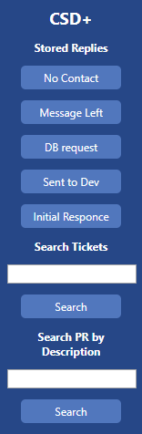Currently there are 5 messages prepopulated in the system, but it has been written modularly so adding new buttons and replies takes minutes.

To use these replies click the button and this will copy the message to your clipboard to then paste into the message window. Be warned this will clear your clipboard and replace it with the generated message.

# Searching

Searching with CSD+ is made a lot easier now that you don’t have to navigate the CSD to search for an open ticket or problem record.

Search Tickets:

Type the ticket number of any active ticket and it will find that ticket.

Search PR by Description:

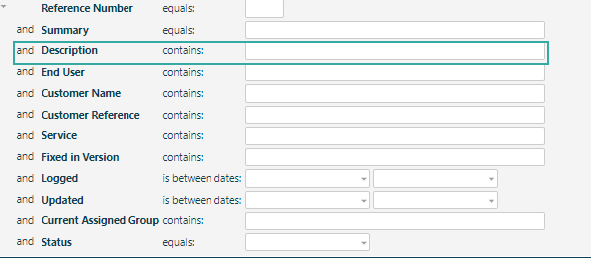This feature will search the description of any problem record in the system.

# Quality of life changes

* Several windows in the CSD have had their height increased for better readability.
* Curves have been removed from the CSD.
* Load time has been added to all windows to better illustrate slowness issues.



* Tab titles have been changed to [Ticket Number] – [Organization]
* Various Minor CSS fixes